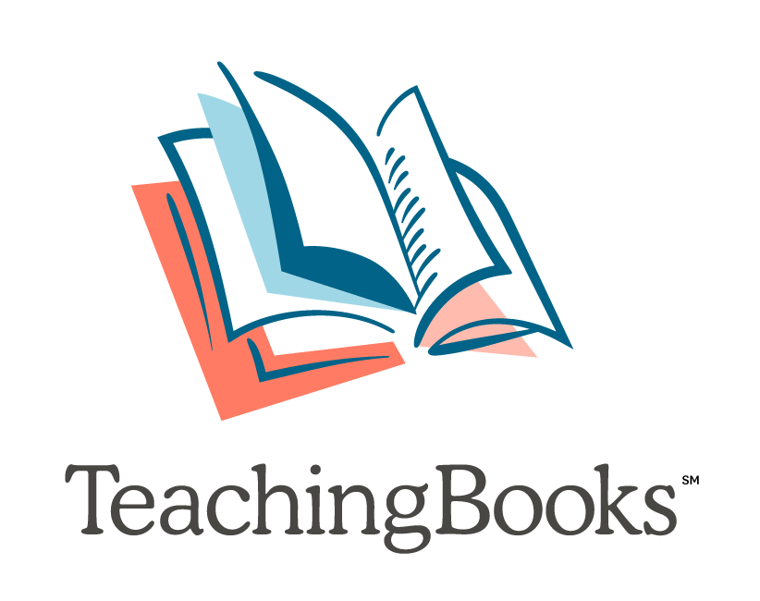

Elementary Virtual Teaching Ideas

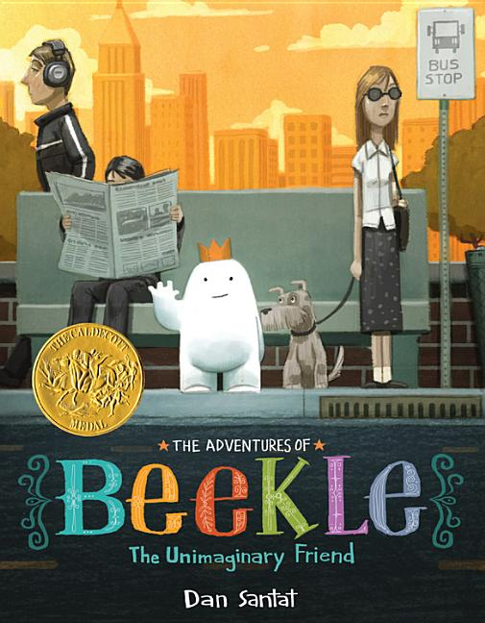
Have you found you need options for students to learn virtually? These ideas can help bridge the gap from classroom to virtual learning.

Complete Book Readings and Accompanying Activities
- The Adventures of Beekle: The Unimaginary Friend by Dan Santat
  - Activity Kit
- The True Story of the Three Little Pigs by Jon Scieszka
  - Activity Ideas
- Wolfie the Bunny by Ame Dyckman
  - Activity Ideas
- Thank You, Omu! by Oge Mora
  - Activity Ideas

Look for more Complete Book Readings on TeachingBooks!

Learn from Authors
- Listen and reflect with these poetry one-a-day activities...
  - Early Elementary
- View these book trailers and predict what will happen in the story...
  - Last Stop on Market Street by Matt de la Peña
  - Rescue & Jessica: A Life-Changing Friendship by Jessica Kensky and Patrick Downes
  - Each Kindness by Jacqueline Woodson
- Learn from authors and write a story...
  - Watch this Meet-the-Author Movie by David Wiesner on picture book-making.
        - Create your own picture book using this Dreamers activity kit.
        - Watch this Meet-the-Author Movie by Kevin Henkes on writing and illustrating.
      - Be a scientist...
        - Shark Lady: The True Story of How Eugenie Clark Became the Ocean’s Most Fearless Scientist by Jess Keating activity kit
        - Ada Twist, Scientist by Andrea Beaty activity ideas
        - Nic Bishop Frogs Meet-the-Author Recording

Professional Development to Do Anywhere!
- Sign up for a webinar or explore our archive of webinars to learn more.
- Complete a Text Complexity Rubric like this one for A Different Pond by Bao Phi and Thi Bui.
- Contact us about scheduling a webinar that your team can access from multiple locations.
- We are here to help! Contact us at 1-800-596-0710 or email accounts@teachingbooks.net.

