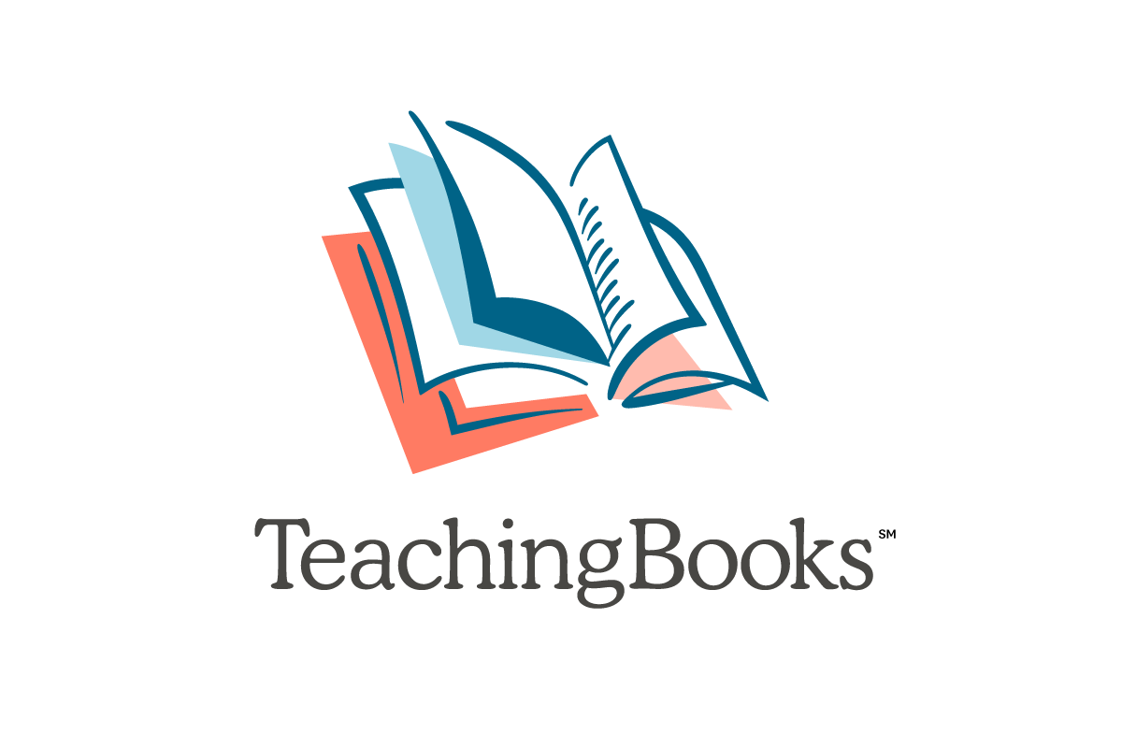
Intermediate Virtual Teaching Ideas

Have you found that you need a few more options for students to learn virtually? These ideas can help bridge the gap from classroom to virtual learning.

Complete Book Readings and Accompanying Activities
- Lost and Found by Anne Schraff (Book 1 of the Bluford High Series)
  - Follow directions on Reading Independently with the Bluford Series.
- The Legend of Sleepy Hollow by Washington Irving
  - Explore the vocabulary activities to better understand the story.
- Talkin’ About Bessie: The Story of Aviator Elizabeth Coleman by Nikki Grimes
  - Select an activity from this book guide.

Look for more Complete Book Readings on TeachingBooks!

Learn From Authors
- Download ready-to-use writing prompts from the Instruct page.
- Have students in upper grades use TeachingBooks author interviews to get to know an author such as Jason Reynolds, Tomi Adeyemi, Aisha Saeed or Benjamin Alire Sáenz.
- Journal with Jack Gantos.
- Explore Ready-to-Use Activities on TeachingBooks.
- Be a scientist and...
  - Listen to Sy Montgomery talk about observation and being an animal scientist. Watch a pet or animal near your home and write your observations.
        - Figure out The Way Things Work with David Macaulay and see if you can figure out how something works. Draw your predictions.
        - Listen to Chris Barton talk about being a scientist.
        - Learn about inventors with Whoosh! by Chris Barton and Don Tate.
      - Locate similar books to those you enjoy by locating a loved title and select Discover Like Books. From there, start a search for connected titles using the filters on the left.

Professional Development to Do Anywhere!
- Sign up for a webinar or explore our archive of webinars to learn more.
- Complete a Text Complexity Rubric like this one for Other Words for Home by Jasmine Warga.
- Contact us about scheduling a webinar that your team can access from multiple locations.
- We are here to help! Contact us at 1-800-596-0710 or email accounts@teachingbooks.net.

Secondary Virtual Teaching Ideas

Have you found that you need a few more options for students to learn virtually?
These ideas can help bridge the gap from classroom to virtual learning.
Complete Book Readings and Accompanying Activities
- The Red Badge of Courage by Stephan Crane
  - Story Map Multi-Leveled Lesson
- Frankenstein by Mary Wollstonecraft Shelley
  - Study Guide
- Romeo and Juliet by William Shakespeare
  - Vocabulary List
  - Short Videos from 60second Recap®
- Develop writing with help from authors...
  - Read Jason Reynolds’ blog post on finding a character’s voice.
  - Listen to S.K. Ali discuss how she wrote for a character in her book.
    - Start journaling as a character.
  - Listen to audio excerpts and review the transcripts for characters Joe and Ravi in Save Me a Seat by Sarah Weeks and Gita Varadarajan.
    - Write two journal entries as different characters.

Look for more Complete Book Readings on TeachingBooks!

Online Activities
- Download ready-to-use writing prompts from the Instruct page.
- Have students in upper grades use TeachingBooks author interviews to get to know an author such as Jason Reynolds, Tomi Adeyemi, Aisha Saeed or Benjamin Alire Sáenz.
- Explore Ready-to-Use Activities on TeachingBooks.
- Locate similar books to those you enjoy by locating a loved title and select Discover Like Books. From there, start a search for connected titles using the filters on the left.

Professional Development to Do Anywhere!
- Sign up for a webinar or explore our archive of webinars to learn more.
- Complete a Text Complexity Rubric like this one for When You Reach Me by Rebecca Stead.
- Contact us about scheduling a webinar that your team can access from multiple locations.
- We are here to help! Contact us at 1-800-596-0710 or email accounts@teachingbooks.net.

